Практическая работа №4
Объектно-ориентированное программирование
ProgressBar , Timer и StatusStrip
Форма 1:
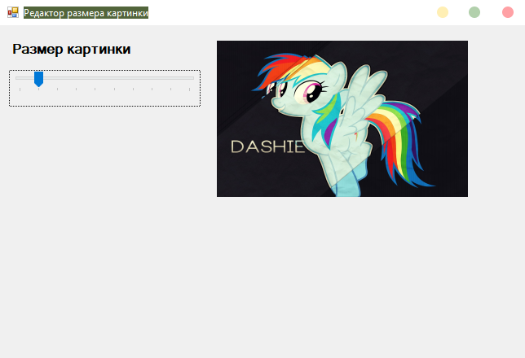
Код формы 1:
private void trackBar1_Scroll(object sender, EventArgs e)
{
pictureBox1.Width = 154 * trackBar1.Value;
pictureBox1.Height = 96 * trackBar1.Value;
}

Форма 2:
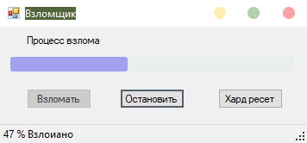
Код формы 2:
private void button1_Click(object sender, EventArgs e)
{
timer1.Enabled = true;
button1.Enabled = false;
}

private void timer1_Tick(object sender, EventArgs e)
{
progress += 1;
if (progress > 101)
{
progress = 100;
timer1.Enabled = false;
}
progressBar1.Value = progress;
toolStripStatusLabel1.Text = (progressBar1.Value+" %"+" Взлоиано").ToString();
}

private void button2_Click(object sender, EventArgs e)
{
timer1.Enabled = false;
button1.Enabled = true;
}

private void button3_Click(object sender, EventArgs e)
{
progressBar1.Value = 0;
progress = 0;
toolStripStatusLabel1.Text ="";
timer1.Enabled = false;
button1.Enabled = true;
}
Ссылка на репозиторий R3inbowshy - https://github.com/R3inbowshy/R3inbowshy-s-Repository

